

**INFORMATION SCIENCE AND ENGINEERING**

**INTERNET OF THINGS (21ISE47A)**

**Practical Activity**

# **CERTIFICATE**

This is to certify that a **Practical Activity** entitled “Speed Detector using Arduino and IR Sensor” is being

Submitted By

Deepak N C (1NH21IS048)

Akash S Cherian (1NH21IS012)

**Signature of the faculty**

**Dr. Vandana CP**

(Associate Professor)

**ABSTRACT**

In the present world, automobiles have played an important role in our day-to-day life. This report represents the design, implementation, and performance evaluation of a speed sensor using Arduino. The objective of this project was to create a cost-effective and reliable solution for measuring the speed of moving objects in various applications. The speed sensor consists of an Arduino UNO, a pair of IR sensors, toy car, jumper wires. The basic principle to find the speed of an moving object is by acquiring the distance and the time taken by the object to cover the distance and hence this project is aimed at finding out the time and the distance of the particular moving object and hence evaluate the speed at which the object is moving.

**TABLE OF CONTENTS**

|  |  |
| --- | --- |
| **CONTENTS** | **PAGE NUMBER** |
| **ABSTRACT** | **1** |
| **LIST OF FIGURES** | **3** |
| **LIST OF SCREENSHOTS** | **4** |
| **1. INTRODUCTION** | **5** |
| **2. REQUIREMENTS** |  |
| **3.1 Hardware Components** | **6** |
| **3.2 Software Components** | **7** |
| **3.METHODOLOGY** | **8** |
| **4. IMPLEMENTATION** | **9-10** |
| **5. RESULTS** | **11** |
| **6. CONCLUSION** | **12** |

**LIST OF FIGURES**

|  |  |  |
| --- | --- | --- |
| **Figure No.** | **Particulars** | **Page No.** |
| 1 | Arduino Uno | 4 |
| 2 | Complete Setup | 4 |
| 3 | IR Sensors | 4 |
| 4 | Arduino Board | 6 |
| 5 | IR sensor | 6 |
| 6 | Data cable | 7 |
| 7 | Bread Board | 7 |
| 8 | Arduino Logo | 7 |
| 9 | Flowchart | 8 |
| 10 | Connected circuit | 9 |
| 11 | Circuit diagram | 9 |

**LIST OF SCREENSHOTS**

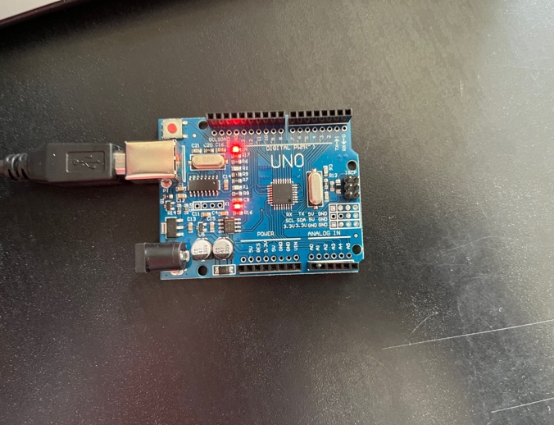 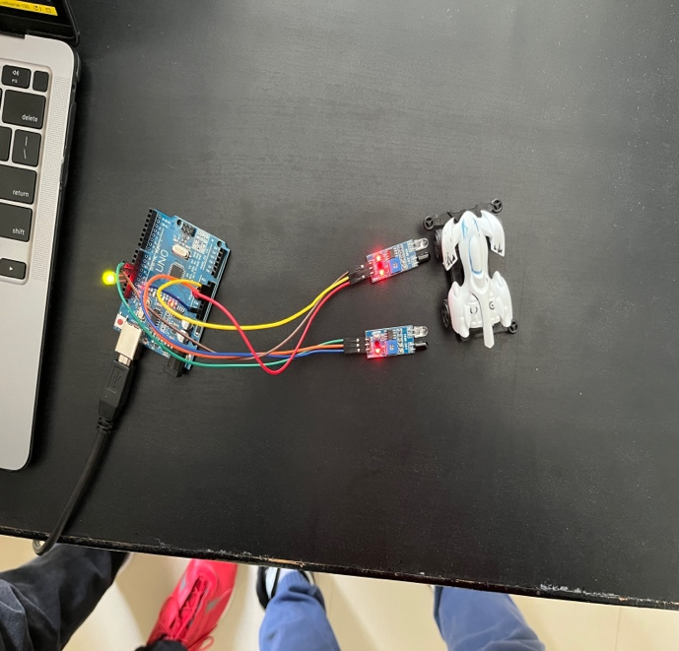

**Figure No:1.** **Figure No:2**

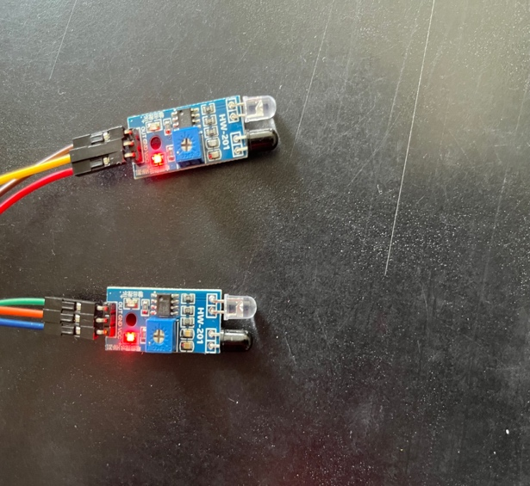

**Figure No:3**

1. **INTRODUCTION**

* Speed sensors are essential devices in various applications, including industrial automation, robotics, automotive systems, and sports analytics.
* The objective of this project is to develop a cost-effective speed sensor using Arduino and an IR sensor, capable of accurately measuring the speed of an object moving through a specific region.
* To find the speed of a given object we basically need the distance covered by the object and the time taken by the object to cover that distance.
* The distance will be already known before hand as the distance between the two IR sensors will be constant
* The time taken will be the time gap between the two sensors when the object passes the first and second sensor

1. **REQUIREMENTS**

2.1 HARDWARE COMPONENTS

* Arduino Board: An Arduino UNO or similar microcontroller with sufficient digital input/output (I/O) pins.

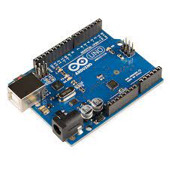

FIGURE NO 4

* IR Sensor: A pair of infrared sensors consisting of an IR transmitter (IR LED) and an IR receiver (photodiode) capable of emitting and detecting infrared light.

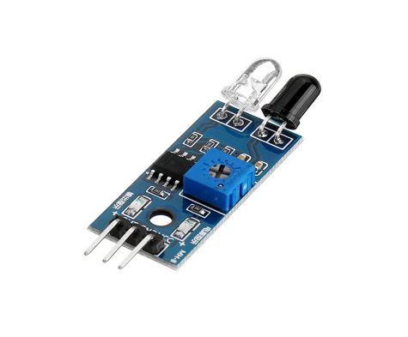

FIGURE NO 5

* Jumper wires: A set of jumper wires for connection
* Data cable: A cable to connect the Arduino with the PC

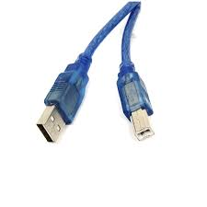

FIGURE NO 6

* Bread Board: To place the sensors

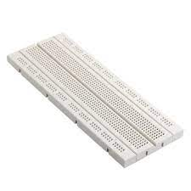

FIGURE NO 7

2.2 SOFTWARE COMPONENTS

* A Computer which contains Arduino IDE software present in it.



FIGURE NO 8

**3.METHODOLOGY**

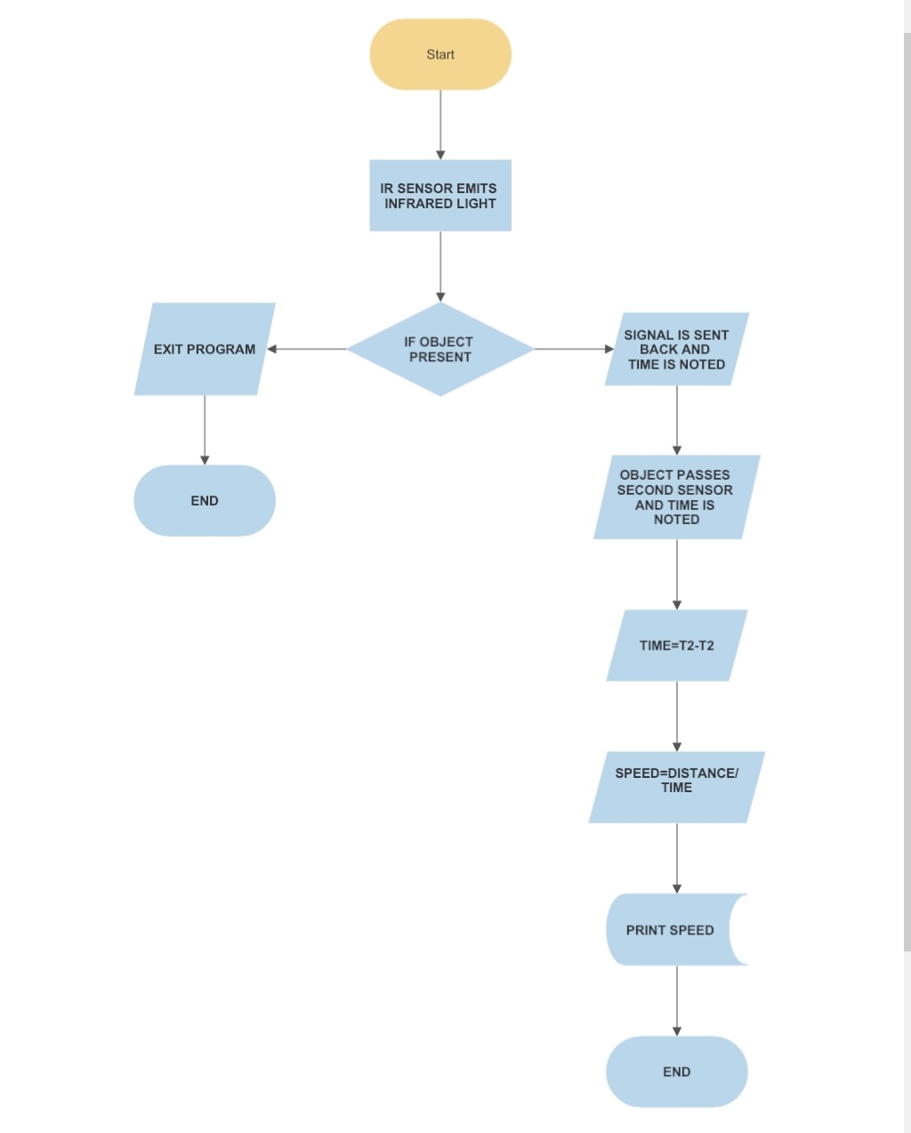 FIGURE NO 9

**4.IMPLEMENTATION**

* System Setup:

Two IR sensors are placed on a breadboard at a specific distance apart and the distance is noted down. The noted distance is implemented in the Arduino code. When the object passes in front of both the IR sensors the value from the IR sensor is sent to the computer.

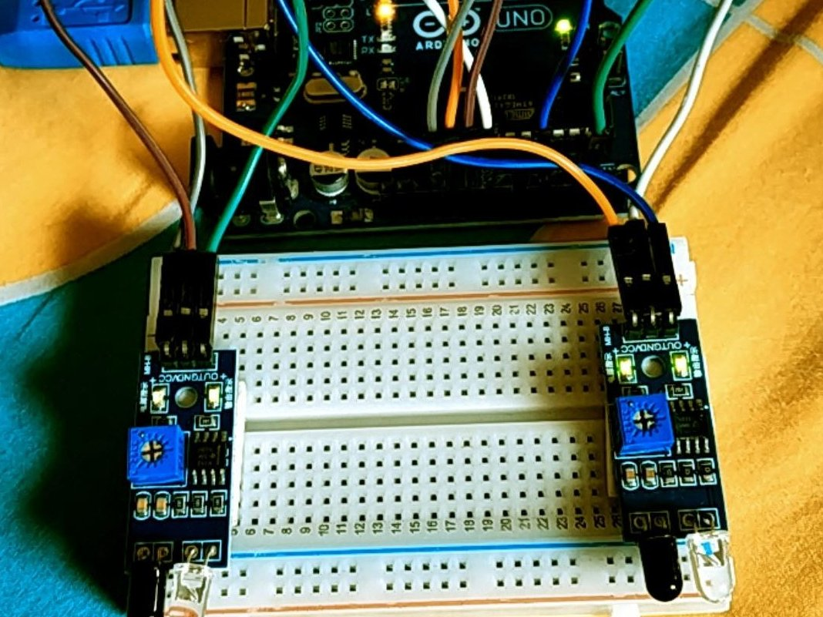

FIGURE NO 10

* Working principle

The IR sensor emits infrared light, which gets reflected by the object and received by the IR receiver. When the IR beam is interrupted by the moving object, the IR receiver's output changes, indicating the presence of the object.

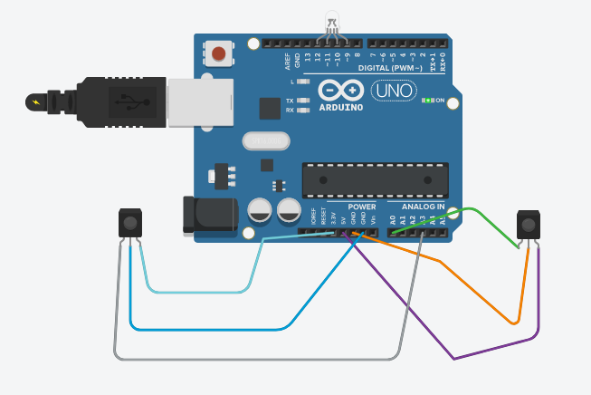

FIGURE NO 11

**SOURCE CODE**

int sen1=11;

int sen2=12;

unsigned long t1=0;

unsigned long t2=0;

float velocity;

void setup()

{

pinMode(sen1,INPUT);

pinMode(sen2,INPUT);

pinMode(13,OUTPUT);

Serial.begin(9600);

Serial.println(" Speed Detector ");

}

void loop()

{

while(digitalRead(sen1));

while(digitalRead(sen1)==0);

t1=millis();

while(digitalRead(sen2));

t2=millis();

velocity=t2-t1;

velocity=velocity/1000;//convert millisecond to second

velocity=(0.5/velocity);//v=d/t

velocity=velocity*3600;//multiply by seconds per hr

velocity=velocity/1000;//division by meters per Km

if(velocity>3)

{

digitalWrite(13,HIGH);

}

else

{

digitalWrite(13,LOW);

}

Serial.print(velocity);

Serial.println(" Km/hr ");

delay(500);

Serial.print(" ");

delay(500);

}

**5.RESULTS**

* The speed sensor was tested with various objects moving through the defined path. The sensor demonstrated accurate speed measurements with minimal errors. The system proved to be reliable and efficient in detecting object speed.
* The speed sensor is not so effective for very large objects but it is very useful to find the speed of smaller objects thereby making this project a small-scale project which is just to understand how a fundamental speed sensor works as well as its construction

**6.CONCLUSION**

The development of a speed sensor using Arduino and an IR sensor showcased a practical and low-cost solution for speed measurement. The IR sensor's simplicity and versatility make it suitable for a wide range of applications, from simple velocity measurements to complex motion analysis in robotics and automation.

* **FUTURE APPLICATIONS:**

The speed sensor can be integrated into various applications, including motion-controlled systems, conveyor belt speed monitoring, sports performance analysis, and traffic monitoring systems, to name a few. Further advancements could include wireless communication for data transmission and integration with other sensor systems for enhanced data analysis.